**Cost-effectiveness analysis of HCC screening in MASLD patients without cirrhosis**

**Background**

Currently, an estimated 25% of the global population has non-alcoholic fatty liver disease (NAFLD, now referred to as metabolic-dysfunction associated steatotic liver disease (MASLD)1. MASLD is becoming an increasingly prevalent cause of HCC globally and in the U.S. due to rising rates in obesity and metabolic disease.

Additionally, HCC incidence in patients without cirrhosis is higher for those with MASLD compared to other liver disease etiologies2. Over a quarter of MASLD-related HCC can occur in the absence of cirrhosis, making surveillance and early detection of HCC challenging in this population3-5. In the U.S. and Europe, HCC incidence in patients with non-cirrhotic NAFLD/NASH has been reported to be 0.1 to 1.3 per 1,000 patient-years2. Despite the relatively lower incidence of HCC among patients without cirrhosis compared to those with cirrhosis, the high prevalence of MASLD is likely to increase the number of HCC cases due to non-cirrhotic MASLD. In fact, in a Veterans Affairs cohort, the annual incidence of HCC among patients with NAFLD was projected to increase 122% by 20302. However, current AASLD guidelines do not recommend regular HCC screening in patients with non-cirrhotic MASLD/NAFLD. Due to the low incidence of HCC in MASLD patients without cirrhosis, it is not considered to be cost-effective to perform HCC surveillance in this cohort6.

Previous studies have shown overweight/obesity, diabetes, male sex, and White, Hispanic, and Asian race/ethnicity in combination with obesity to be associated with higher HCC incidence7. Additionally, studies report that 20-25% of patients with HCC cirrhosis were not aware of their cirrhosis prior to being diagnosed with HCC, especially among older patients and those with NAFLD8-11. Therefore, an underdiagnosis of cirrhosis could play a factor in reducing access to HCC surveillance among patients with MASLD. However, there are no cost effectiveness analyses (CEA) performed to further stratify the non-cirrhotic MASLD population to identify a group with higher risk of HCC in which HCC surveillance would be cost-effective.

We aim to perform a CEA to identify a high-risk population among patients with non-cirrhotic MASLD in which HCC surveillance would be cost-effective. The results of this study could help inform practice guidelines to improve the early detection and outcomes of HCC in patients with non-cirrhotic MASLD.

**Objectives**

1. **Primary objective:** Determine the cost-effectiveness of conducting HCC surveillance in patients with non-cirrhotic MASLD in the U.S.
2. **Secondary objectives:** Evaluate the impact of demographic (age, sex, race/ethnicity) and clinical variables (platelet, INR, FIB-4, diabetes, overweight/obesity) on HCC incidence in the non-cirrhotic MASLD population to determine a high-risk group in which HCC screening would be cost effective.

**Study Design and Methods**

**Population and setting**

Our study population will include adult patients (³18 years) in the U.S. who have non-cirrhotic MASLD. Sub-group analyses will be performed by demographic and clinical variables.

**Study Design**

The intervention arm will be patients with non-cirrhotic MASLD who receive regular HCC screening (biannual abdominal ultrasound and AFP). The control arm of this study will be all patients with non-cirrhotic MASLD who do not receive regular HCC screening.

We will conduct sub-group analyses to determine the cost effectiveness of conducting HCC screening in patients with various combinations of demographic and clinical characteristics that could impose higher HCC incidence. The cost-effectiveness of these groups will be compared to that of conducting HCC screening in all patients with non-cirrhotic MASLD.

**Time:** Utility and costs will be evaluated across a lifetime horizon.

**Discount rate:** 3% annual decrease in both cost and utility (as recommended by the Public Health Service Panel on Cost-Effectiveness in Medicine, Lipscomb et al., 1996)

**Measured outcomes:** The quality adjusted life years (QALYs) will be calculated using the estimated quality (quantified value ranging from 0-1) and length of life. The length of life will be estimated by the CEA model and will be validated using real-world data.

All costs will be determined from the payer’s perspective and will be converted to USD in 2024.

The incremental cost effectiveness ration (ICER) will be calculated for the intervention arms compared to the control and will be interpreted with reference to the contemporary willingness to pay threshold (WTP) of $100,000 or $150,000.

**Model and assumptions:**

**Key Idea**

We want to measure the cost-effectiveness of screening MASLD non-cirrhosis patients. We assume that screening improves earlier detection and so lowers the death rate from HCC classes.

**Sex and Age**

We have the target distribution populations by four buckets for (Dead, HCC, Cirrhosis) and the initial population distributions. This allows us to:

1. derive a weighted transition probability for the population, we do not need to simulate different patient, but only the average patient in the distribution
2. We can simulate different distributions of input populations to find cost-effective subgroups

We assume that the age and sex distribution will be uniform across the above HCC stages upon diagnosis.

We used the Truven database to find the distribution of patients in the age groups 18-30, 31-40, 41-50, 51-60, 61-70, 71-80, 81-90, and 91-100. The age-dependent probability of death is added onto the annual rate of death for patients in the MASLD node. Once a patient reaches an age of 100, the patient is transitioned to the death node regardless of their health state.

**Undiagnosed vs Non-cirrhotic patients in MASLD population**

We specify a distribution of undiagnosed cirrhosis (A) and non-cirrhosis patients (B). They have the same health and utility measures. The following probabilities are weighted:

* Transition to Death, different for A and B
  + Underdiagnosed cirrhosis to death transition is same as cirrhosis in literature
* Transition to HCC, different for A and B
  + Underdiagnosed cirrhosis to HCC transition is same as cirrhosis in literature
* Transition to cirrhosis, different for A and B

**Control vs Intervention**

We model all HCC states, early, intermediate, late as a single HCC node. The HCC node is composed of three buckets, for each disease health state. In a given simulation scenario, a patient in the HCC node has parameters reflecting the HCC node’s weighted distribution. Control scenario is differentiated from Intervention by specifying a different HCC weighting distribution. Each scenario has a fixed HCC disease distribution.

*Example of HCC node distributions*

* *Simulation: Control*
  + *Early : 30%*
  + *Intermediate : 40%*
  + *Late : 30%*
* *Simulation: Intervention*
  + *Early : 80%*
  + *Intermediate : 15%*
  + *Late : 5%*

For a given disease distribution, we derive a weighted average utility, reward to transition to next stages, which are fixed for all given simulations and patients- the costs of procedures and types of procedures and transition probability to procedures is the same for a given HCC disease state.

Intervention should have a distribution skewed towards earlier-stage forms of the disease, as screening would identify the disease earlier, leading to better health utilities and lower costs.

*Calibration of HCC Control disease distribution*

Calibrating the control distribution is a difficult task, as there are few natural available literature sources. Calibration will be done by simulation and choosing reasonable death survival curves outcomes. It suffices to run a two-parameter simulation Early in [10,20,30,40,50,60,70] and Late in [5,10,15,20,25].

*Calibration of HCC Intervention disease distribution*

Similar to above, we run the simulations with a two-parameter calibration.

*Cost-effectiveness analysis*

Once we have data with reasonable death curves, we get outputs for at least 40 control scenarios and 10 intervention scenarios. This gives us a map with axes being early/late control proportions, for a given intervention scenario. The cost-effectiveness frontier for each HCC global incidence is drawn, with specific lines highlighted for a various HCC incidence types.

Lines can also be drawn for different cost curves of screening.

*Simulation Capacity*

The above algorithm requires to run the simulation number_of_control*number_of_incidences which is about 500-2,000. Given that one run is about 1s, this should run in 20 min to an hour (without speedups).

**Censoring**

We censor patients that develop cirrhosis. In the simulation that means creating a cirrhosis state with zero utility and zero costs. If a patient goes to HCC and develops cirrhosis, we do not censor them.

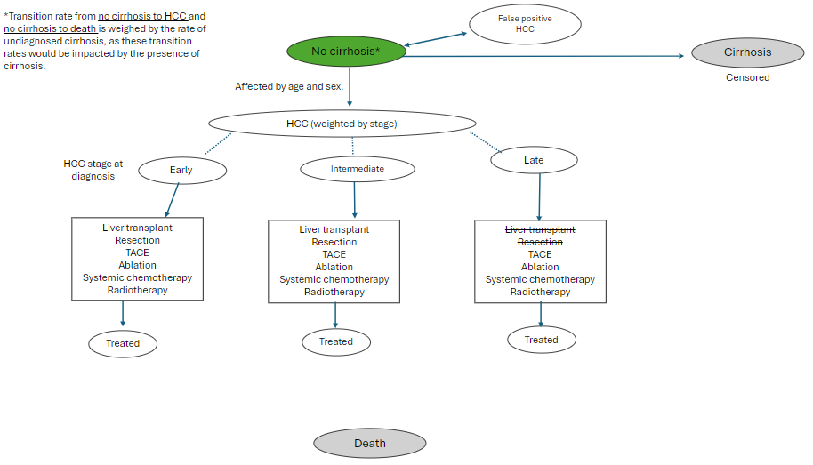**Figure 1:** Framework of the Markov Model representing the health state transitions of patients with non-cirrhotic MASLD.

Each health state above is dependent of what is diagnosed or known by the patient/doctor. Therefore, we will account for the underdiagnosis of cirrhosis in MASLD patients by including patients with undiagnosed cirrhosis in our cohort. Based on literature, we will determine a certain proportion of our “non-cirrhotic” MASLD group to start in the compensated cirrhosis stage.

**Modelling Approach**

We generate 100,000 MASLD non-cirrhosis individuals, we conduct a simulation for each of the patients through the health states and collect a QUALY (utility) and a total cost (reward) value. This allows us to measure cost-effectiveness after running scenarios for each individual and then deduce group outcomes.

**Utility and Reward Definitions**

We calculate these values statically, not dynamically. If a health state sequence is [CC, HCC, HCC, D], then the utilities/rewards are based on values assigned to the states CC, HCC, HCC, D and not the transitions CC- HCC and HCC-HCC and HCC-D. We use uniform discounting.

**Subgroups Detection**

Based on our model, we can do the following:

* Analyze CE for the whole population
* Calculate CE for a given subgroup
* Deduce from the whole-population simulation which subgroups are most CE
* Derive mathematical parameterizations that are sufficient for a future subgroup to be CE (in expectation)

**Calculation of age-dependent rate of death from MASLD (no cirrhosis or HCC)**

The total death rate is the sum of the probability of liver-related death from MASLD (weighed, takes into account undiagnosed cirrhosis) and the probability of death due to older age. We assume that at age 18, there is no additional cause for death due to age, so at age 18, prob of death is just the liver-related prob of death from MASLD. With every increase in age from 18, we add the incremental increase in death probability due to age, from the actuarial life table provided by the Social Security (2021 period life table for the Social Security area population, as used in the 2024 Trustees Report (TR): https://www.ssa.gov/oact/STATS/table4c6.html).